|  |  |
| --- | --- |
| final logo jawi UTeM-01 | FAKULTI TEKNOLOGI MAKLUMAT  DAN KOMUNIKASI  UNIVERSITI TEKNIKAL MALAYSIA MELAKA  BITS 3363 – NETWORK SECURITY  PROJECT MANAGEMENT |

**Title: Project Cost Development**

**MEETING 1: PROGRESS REPORT**

**(Group name - domain area: client name)**

**Group KeepAlive -** Car Manufacturer – Proton

**GROUP MEMBERS (MAXIMUM 6 PERSONS IN A GROUP)**

1. Muhammad Izham Bin Norhamadi (B032020039)
2. Ahmad Sha Herizam Bin Tahir (B032020009)
3. Muhammad Rifqi Bin Ramlan (B032020028)
4. Muhammad Imran Bin Rosli (B032020043)
5. Affendy Elyas bin Azhari Sharidan (B032020024)
6. Muhammad Firdaus Hafizi bin Sabri (B032020037)

Date: 6/11/2021

1. **INTRODUCTION**

* Example: If at Implementation Stage of IDS Server, what kind of service of IDS? Is it threat detection or threat monitoring? How long it is going to take to develop the IDS? How many talent / staff for developing the IDS? How much it cost to pay the talent per hour and how much cost involved to buy the part of the IDS system.
* Figure 2 illustrates the WBS of the project.

Our project revolved around setting up the E-mail server as well as the appropriate services to go along with it. This project purpose is to provide our company employees secured way for exchanging email whether from inside or outside of our network. The time allocated for the completion of this project is estimated around 95 of working days. There are around 12 employees from our company that has been appointed as database administrator and network engineer as our talent resources in order to assist us to complete this project. The estimated cost to finish this project is around RM43,000 funded by our company.

Our project also setup a SpamTitan as security services with the various features in SpamTitan for our company. SpamTi tan is for email protection by blocking spam, viruses, malware, ransomware, and links to malicious websites from your emails. The time allocated to install this service only take approximately one hour. The cost of this service is RM 4 per user for each month.

1. **Work Breakdown Structure (WBS)**

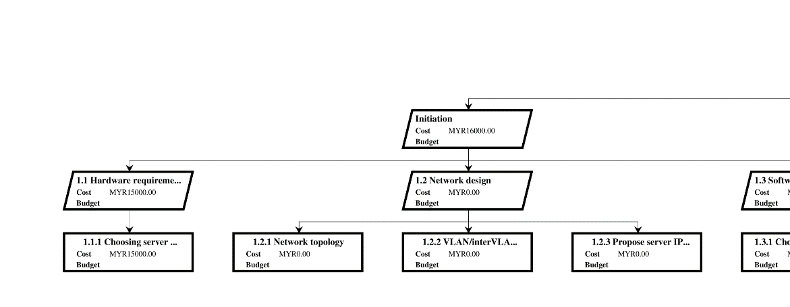

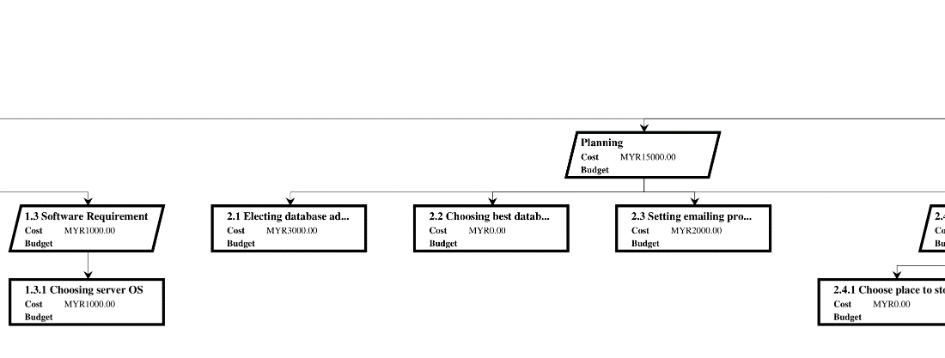

Figure 2: Work Breakdown Structure

1. **GANTT CHART**

* In initiation phase, it takes only 10 days because the phase consists of general task like choosing server and routers, making network design and choosing which OS need to be install in the server.
* In planning phase, it takes 7 days. It consist of task that need a short time to do for example electing database administrators.
* Execution phase take the longest time which is 56 days, and the 2 task that hogging the time taken is installing hardware and improve site performance that taking a total of 42 days.
* Control consist of many maintenance task such as monthly maintenance, check server integrity and security check up and it need 15 days to completed.
* The last phase is closing that only take 9 days.

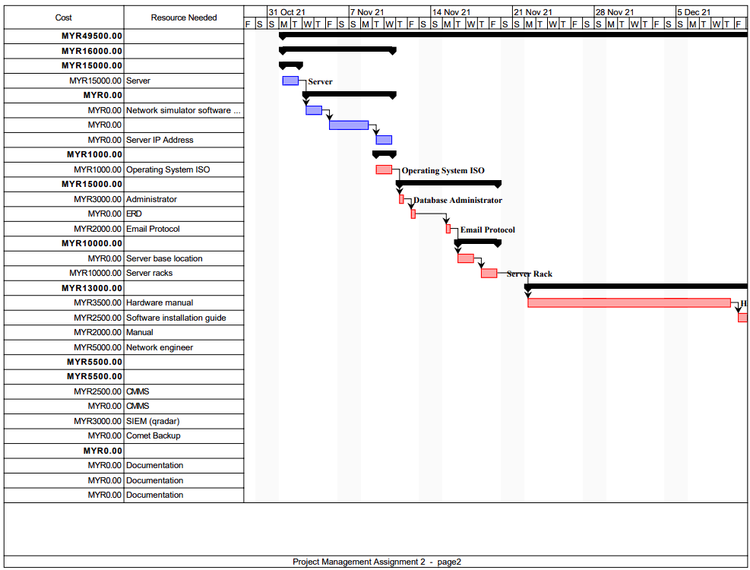

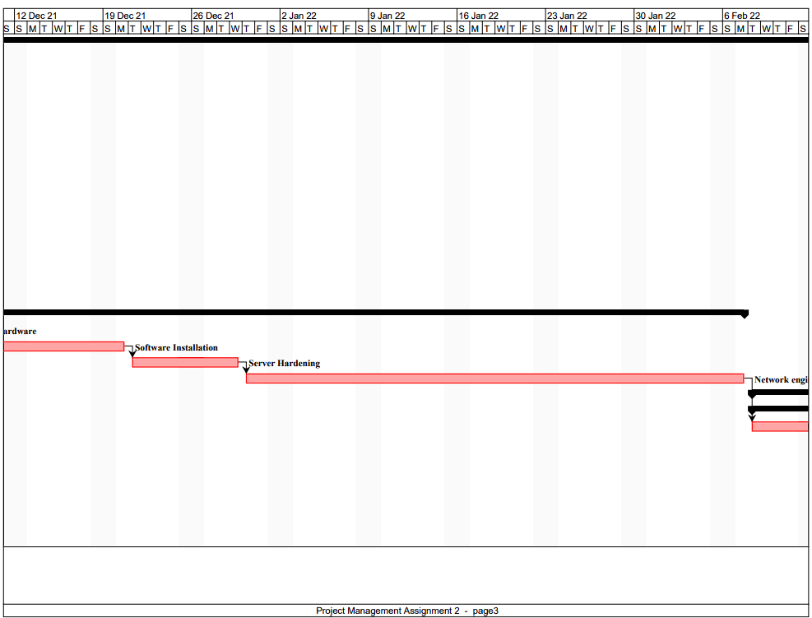

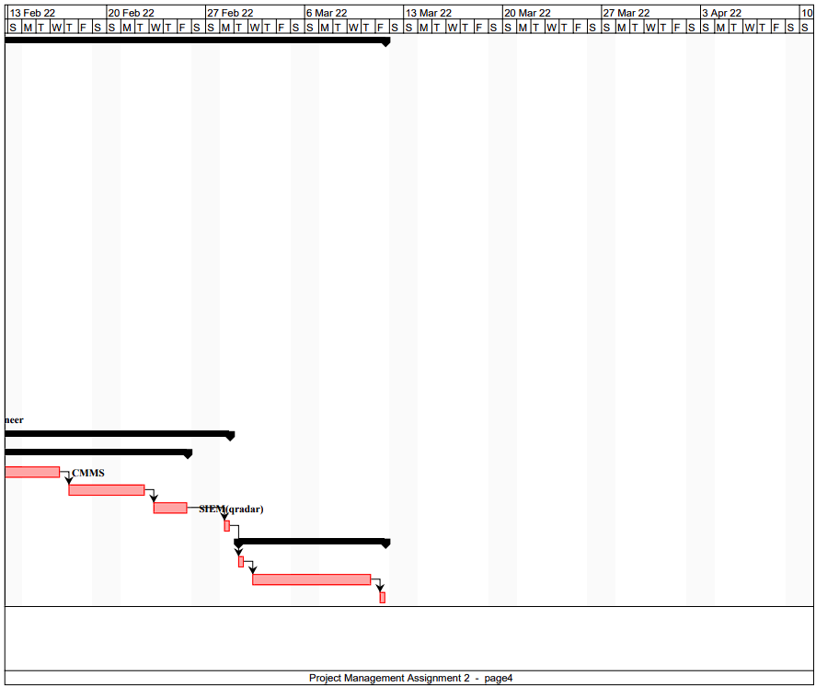

Figure 3: Gantt Chart

1. **NETWORK DIAGRAM**

FIgure 4: Network Diagram

1. **TASK USAGE**

Figure 5: Task Usage Table

1. **RESOURCES**

Figure 6: Resource Table

1. **CONCLUSION**

Lesson learned during implementation:

* 1. Work in a team and have a good decision-making
  2. Get new information while working with new implemented software
  3. Recognize weaknesses of software and server to be paid attention to.
  4. Difficult to determine the suitable place to store hardware.

Strategy to protect the assets and talents in the organization from harmful cybercrimes.

* 1. Always keep the equipment up to date.
  2. Keep maintenance of software and server in regular basis.
  3. Implement multi-factor authentication before accessing the system.
  4. Install security measure digitally and physically for the software and hardware.

In conclusion, implementing a big project need to have a well-prepared plan to ensure the flow of works are being manage properly phase by phase. This is why a simple diagram such as Gannt Chart is extremely important to make sure every works is well executed within the given time. This is also to make sure every aspect of a project can be managed properly such as cost, condition of hardware and assets. This will impact positively toward the management of the project while also team member can gain new knowledge while implementing it and overcome any obstacles along the way. Having these obstacles can teach all the team member to have an organized strategies to make sure every properties and assets is maintains and saves from any type of cybercrimes.

**Assessment: [Meeting 1] – (5%) – [PO7, TS1]**